The First Part Last

Name___________________________________________

Author’s name________________________________________

Pre-reading Writer’s Notebook Entry
How do you think your life would change as a teenager if you suddenly had the responsibility of an infant? Make a schedule of your life as it is now and then make a new one based on a life with baby.

Pre Reading Research
Find the most recent statistic you can find about teen pregnancy and write how you got that information (step by step)

Now (p. 3-4)
1. How old was the narrator when he was finally able to sleep through the night?

2. What did his mom do when he couldn’t sleep?

3. What is the narrator’s baby’s name and how old is she?

4. The narrator describes “sweet new baby smell” as smelling like these three things:
1.

2.

3.

5. What is the tone or attitude in this chapter? Think about feelings/emotions of the narrator.

Then (p. 5-6)
1. What are the names of the narrator’s two friends?

2. Based on an inference, what is Mineo’s?

3. What is the narrator’s father’s name?

4. What’s the narrator’s favorite dinner?

5. What was waiting for Bobby as soon as he got home?

6. Based on what you know, make an inference about what Nia will tell Bobby.

Now (p. 7-11)
1. Describe “Just Frank.”

2. Why was Bobby wondering if he would be “a man, a good man”?

3. What is the narrator’s mom’s name?

4. Describe J.L.

5. Describe K-Boy.

6. Which friend asks Bobby if he’s going to keep Feather?

Then (p. 12-13)
1. Which of Bobby’s parents cries?

Make a connection: How do you think your parents would react to finding out that you were going to have a baby? Write at least 3 sentences.

Now (p. 14-17)
1. If it wasn’t Bobby that came up with “The rules,” who can you infer that it was?

2. When the baby wakes up, what does she want?

3. Why does Bobby list all of those items?

Then (p. 18-21)
List some of the things in the house Bobby grew up in.

Describe the house Nia lives in.

Why is Nia’s mom smiling?

Now (p. 22-25)
1. Where is the setting of this chapter?

2. What is the pediatrician’s name?

3. What did Bobby do that “kind of messed” him up?

4. Who made Feather’s booties?

5. How is Bobby feeling?

6. For shat does Bobby want to beg the doctor?

Then (p. 26-29)
1. Where are Bobby and Nia in this scene?

2. How is Nia acting in this scene?

3. How does the doctor smile at Bobby?

Now (p. 33-36)
1. Where did Feather spend last night?

2. What was wrong with her?

3. Describe Coco.

4. On page 36 Bobby says, “ … which pisses her off and makes her scream, and then I look around my room and miss me.” Explain what he means.

Then (p. 37-41)
1. How did J.L. and K-Boy react to the news?

2. How does Bobby describe Nia’s reaction?

3. What did Bobby do at the flower shop?

Make a connection: How would you react to your best friend telling you that they were having a baby? Do you think that he/she is ready?

Now (p. 42-46)
1. Why is Bobby sleeping in Brit Lit.?

2. Who is Jackie?

Then (p. 47-50)
1. What are two foods that Nia is craving?

2. Of what is Bobby afraid?

Now (p. 51-54)
1. What favor did Bobby ask of Coco?

2. Bobby is hinting at something bad happening. Make an inference about what it could be, based on the reading.

Then (p. 55-57)
1. What did Bobby and J.L. do in Nelson’s room?

2. Why wasn’t Bobby able to see Nelson’s reaction?

3. Where is Nia, and why?

Now (p. 58-61)
1. What is Bobby doing in this chapter?

2. Why does he begin to cry?

3. “I’m the pale white ghost boy beside the brown girl who is always looking away.” Who does the brown girl represent?

4. What does Bobby say about his brothers?

5. Whose hand is on Bobby’s shoulder at the end of the chapter?

Then (p. 65-69)
Looking for details. List some of the sensory images in this “fairytale” chapter.

See:

Hear:

Taste:

Smell:

Now (p. 70-75)
1. When Bobby finds out it’s 7:30, what is he worried about?

2. Which parent is Bobby more afraid of?

3. Who does Bobby place a phone call to?

4. What does Bobby see through the taxi window?

Then (p. 76-80)
1. Name four things that are bothering Nia, physically.
1.


2.

3.

4.

2. Why is Nia crying?

Now (p. 81-82)
1. Name three things that make Bobby feel old.
1.

2.

3.

Then (p. 83-87)
1. Where is the setting of this chapter?

2. How is Bobby feeling?

3. What’s the difference between this party and the Bat Mitzvah?

4. What doesn’t Nia want to do?

Now (p. 91-96)
1. Why does Paul name his kids Nick and Nora?

2. What makes Bobby’s dad and mom laugh from the kitchen?

3. What does Bobby’s mom do that shocks him?

4. What’s the name of the town Paul lives in?

5. What are Bobby’s plans for the following year?

Then (p. 97-100)
1. Name 3 things Bobby dreams that he and Nia could do if they give up the baby.
1.

2.

3.
2. What is the social worker trying to help them do?

Now (p. 101-104)
1. Why does Bobby’s dad leave the door open?

2. Compare that to Bobby’s mom. What does it say about each of his parents?

3. When Bobby moves to his dad’s, what is he surprised to see his mom doing?

4. How do you think Bobby’s feeling at the end of this chapter and why?

Then (p. 105-107)
1. Who cried in this chapter?

Now (p. 108-112)
1. What did Jackie tell Bobby that surprised him?

2. Why did the boys skip school and head out of the city?

3. At the end of this section, what does Bobby tell Feather about?

Then (p. 113-114)
1. What is Bobby singing to Nia’s stomach?

Nia (115-116)
1. Name four reasons why Nia dreamt of being a firefighter.
1.

2.

3.

4.
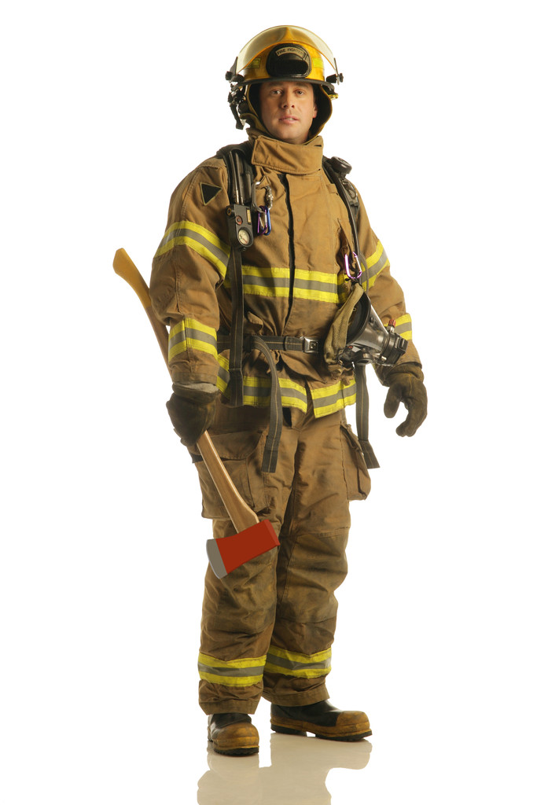

Now (p. 117-119)
Name 3 things that Bobby tells Feather about Nia.
1.

2.

3.

Then (p. 120-127)
1. Why was Bobby running and crying?

2. What did Bobby want to tell Mr. Wilkins?

3. What picture does Bobby carry with him?

4. On page 124, we get an idea as to how Feather got her name. Write the quote below:

5. What does Bobby tell the social worker that he is not going to do?

Now (p. 128-130)
1. Name the city and state where Bobby is thinking of going.

Heaven
1. What did Bobby hear his mom telling Feather?

