New Paltz Central Schools
Athletic Handbook For
Players, Parents/Guardians, Coaches, & Fans
2015-2016
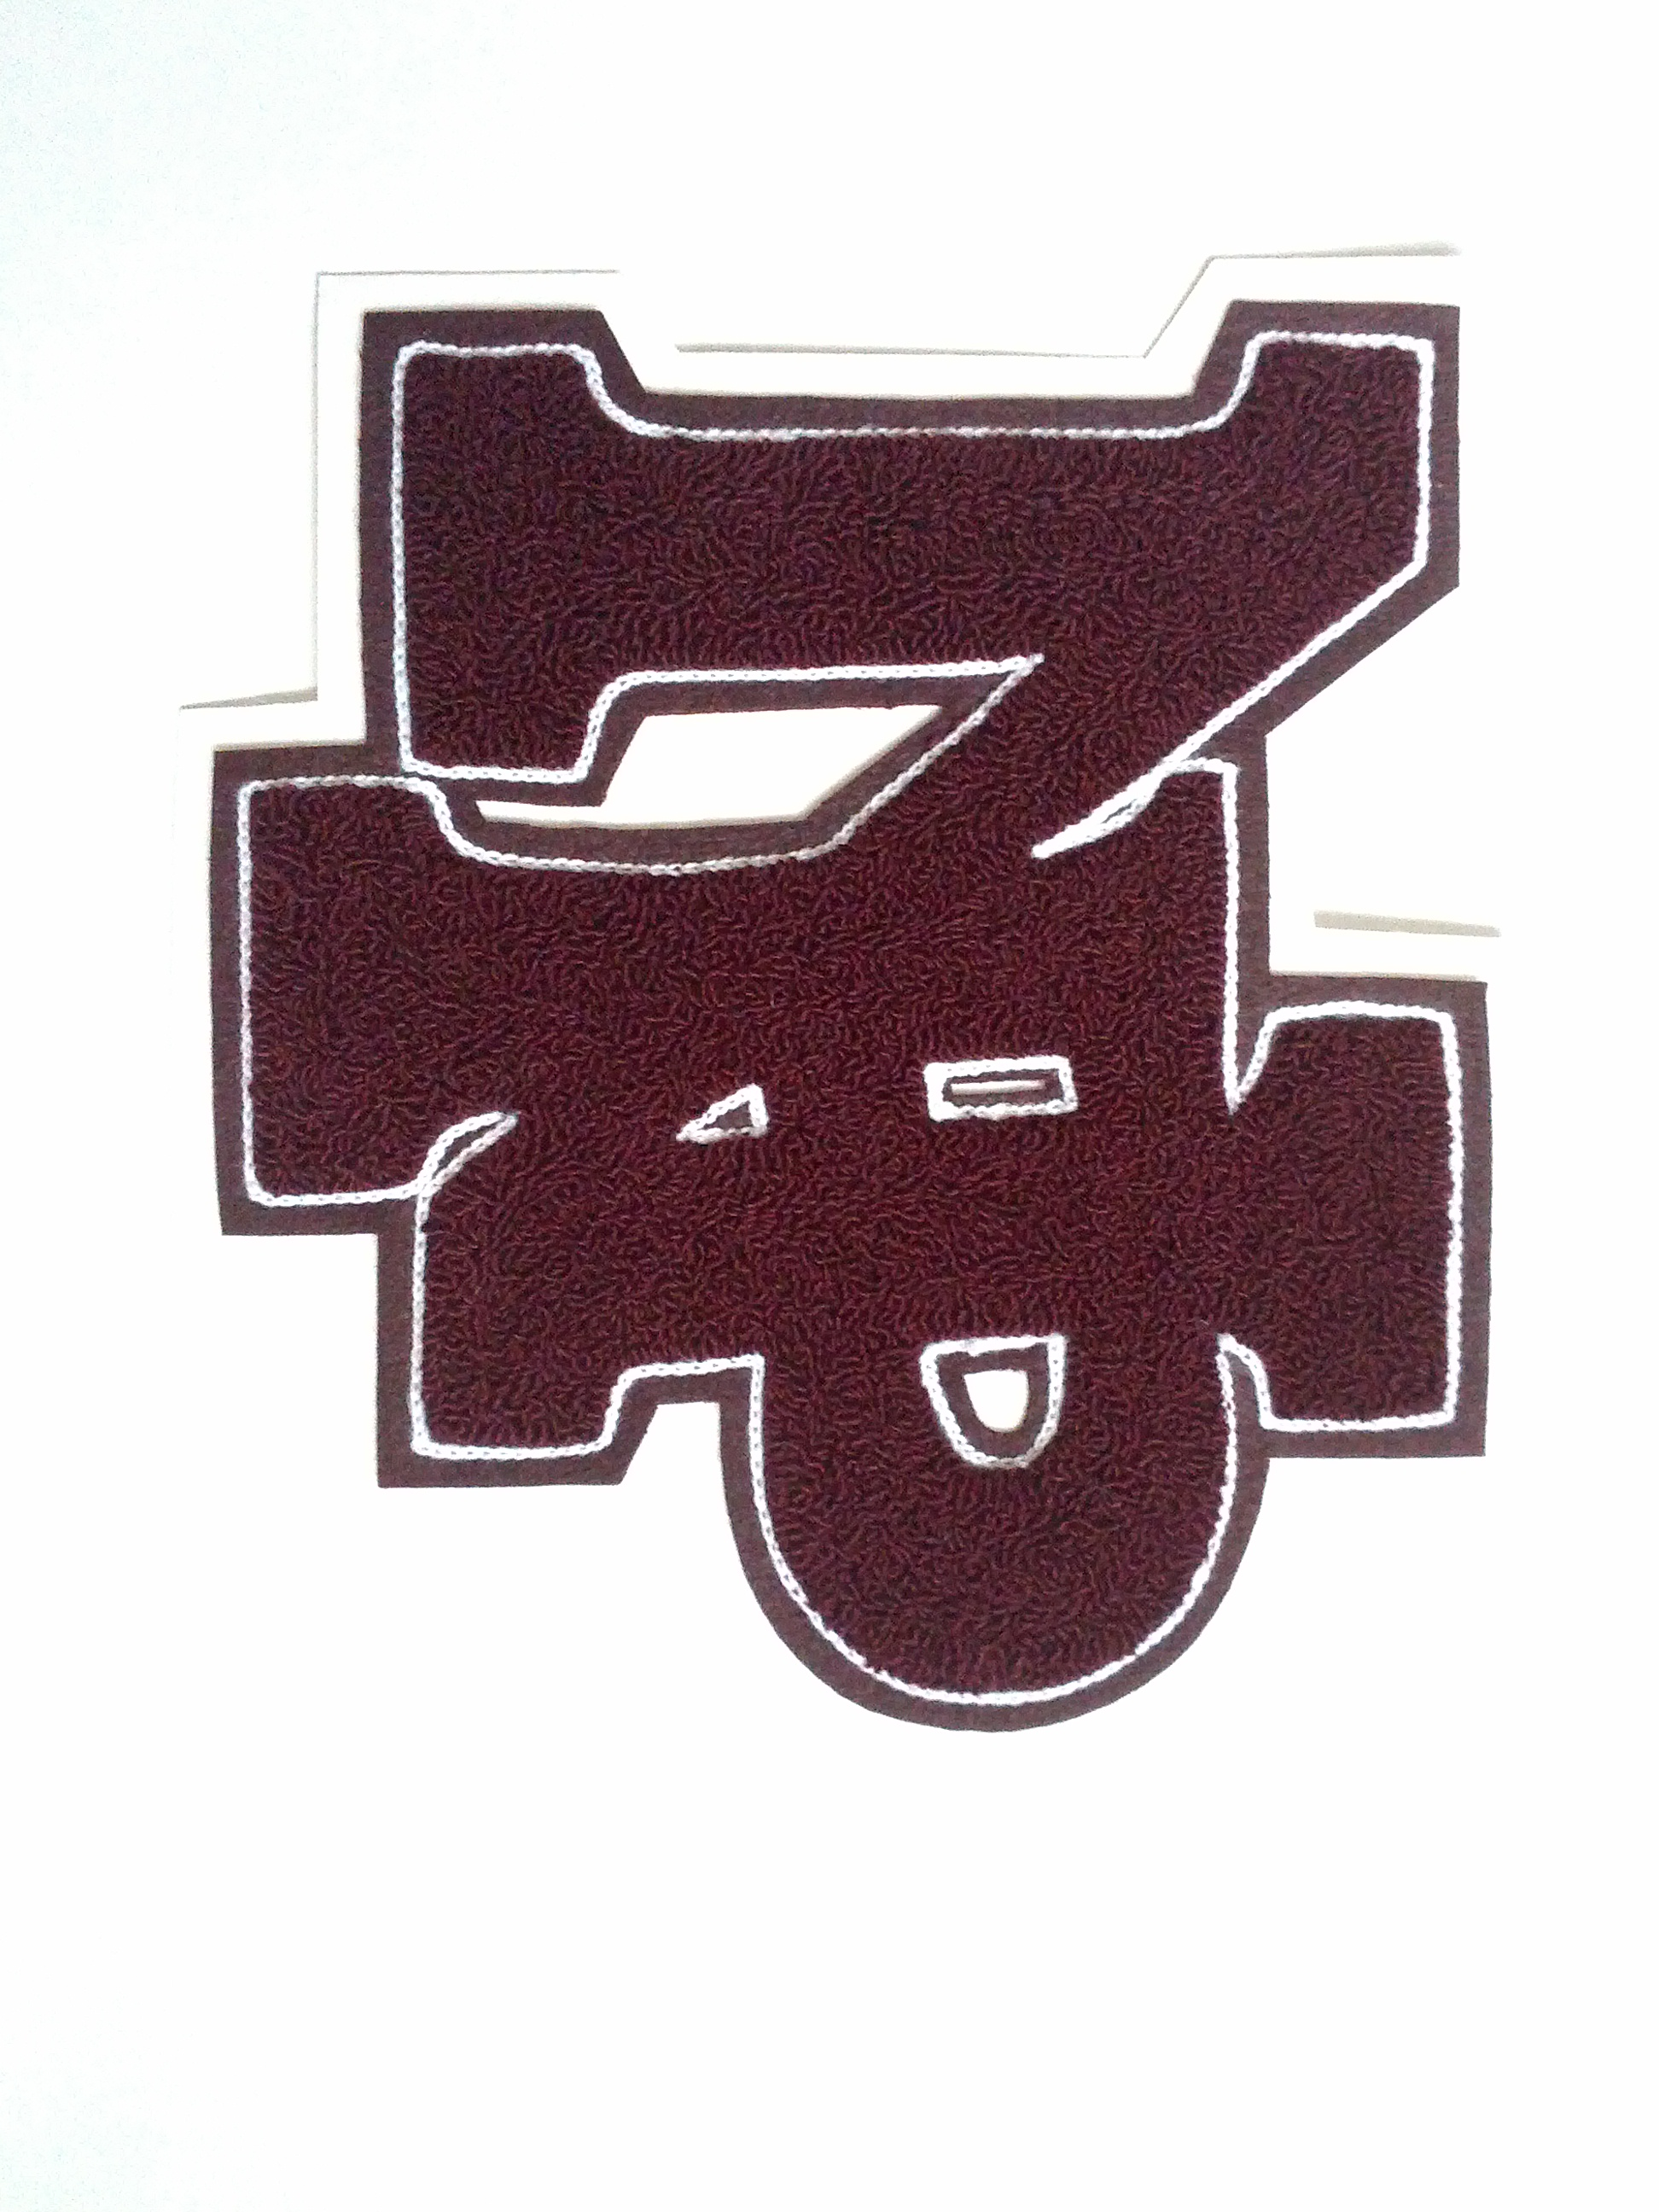

Mrs. Antonia Woody
Director of Athletics
Revised 6/23/15

Be Loud, Be Proud, Be Positive !

Warning: Participation by a student in athletic activities involves some degree of risk of physical injury. Such physical injury can occur in any type of sports activity, be it a contact or a non-contact sport. By volunteering to participate in a school sponsored athletic activity, a student and his/her parents acknowledge the potential for an accidental physical injury or death to occur.

PHILOSOPHY
The athletic program, is an extension of New Paltz School District’s academic goals and ideals, and is an important and integral part of the total educational experience. As such, all involved accept the responsibilities, rules and regulations that are unique to an interscholastic athletic program. Open to voluntary participation by all students the program places high expectations on athletes with regard to time, behavior, energy, commitment, and loyalty. Interscholastic athletics, unlike recreational sports are not “just play.” Athletes, coaches, parents and fans are the school’s most visible representatives and are expected to display acceptable and appropriate behavior both in and out of the playing arena.

“The experience of participation in athletic activities is designed to foster the quest for excellence by creating an educational and competitive experience within an atmosphere of sportsmanship. To develop individual and team potential by promoting high standards of competence, character, civility and citizenship.

Coaches, Student-athletes and Spectators, should demonstrate:
Competency - knowledge and possession of skill, strategies, fitness, healthy behaviors
Character - responsibility, accountability, dedication, trustworthiness, fair play , self-control
Civility – respect toward others, fairness, caring for self, team and opponents
Citizenship – loyalty, commitment, teamwork, role modeling”
(NYS Framework for Athletics)

An athletic contest is only a game, not a matter of life or death for a player, coach, school, official, fan or community. “We do not always win, but we succeed when we continually STRIVE to WIN. Winning is not everything, but making the effort to win is!” - Vince Lombardi

Participations in interscholastic athletics is a privilege and not a right and those who are unwilling to uphold these high expectations may be subject to consequences.

Please remember that joining an athletic team is a large commitment of not only the athlete’s time and efforts but those of the athlete’s parents and/or guardians as well.

MODIFIED PROGRAM PHILOSOPHY
This program is available to all students in the seventh and eighth grades. At this level, the focus is on learning athletic skills, game rules, fundamentals of team play, strategy, socio-emotional growth, and healthy competition.
At the modified level, the number of teams and size of the squad will be determined by the availability of financial resources, qualified coaches, suitable facilities and a safe environment.
Practice sessions are vital in order for the desired development of the adolescent athlete and team to occur.. League rules dictate that playing time for all players be equitable. Opportunities for meaningful contest participation for each individual will exist over the course of a season based on attendance, commitment, attitude and behavior.

JUNIOR VARSITY PROGRAM PHILOSOPHY
The junior varsity level is intended for those who display the potential of continued development into productive varsity level performers. Team membership is usually dominated by ninth and tenth graders. Eighth graders may also be included provided they have satisfied all Athletic Placement requirements.
At this level, athletes are expected to have committed themselves to the team, program and continued self-development. Emphasis on physical conditioning, refinement of skills, elements and strategies of team play in addition to emotional development is increased. The outcome of the contest is a consideration at this level while still working towards team and player development.
The junior varsity player must realize that practice sessions are important and vital if the program is to be successful. Meaningful contest participation will exist over the course of the season, but specified amounts of playing time are not guaranteed. While contests and practices are rarely held on holidays and Sundays, practices may be held during school vacations. With the goal of becoming a varsity athlete in sight, a high level of dedication and commitment is expected at the junior varsity level.

VARSITY PROGRAM PHILOSOPHY
Varsity competition is the culmination of the scholastic sports program. The roster will consist mainly of juniors and seniors. Occasionally, freshman and sophomores will be included if there is evidence of advanced skill levels, physical and socio-emotional development. In sports where there are no junior varsity level teams, the varsity roster may consist of freshmen and sophomores as well as juniors and seniors. Seventh and eighth graders may also be included provided they have satisfied all Athletic Placement requirements.
Squad size at the varsity level is limited. Conducting effective and meaningful practices, skill level, playing time, along with commitment, attendance, attitude and behavior are considered when choosing the team. Each team member will have a role(s) and be informed of the importance of this role. The students' acceptance of this role will determine, to some degree, roster positions. Contest participation over the course of the season is desirable but is never guaranteed.
To gain a position on a varsity team, the participant must have a sound attitude and possess an advanced level of skill. The realization that a varsity sport may require a six-day-a-week commitment is important. This commitment is often extended over vacation periods and should be taken seriously.

PARTICIPATION REQUIREMENTS-
No students may begin practice unless they and their parents have completed permission forms, have a current physical performed by a NYS licensed physician, physician’s assistant or nurse practitioner, an Health History update, agreed to the training rules, and completed the Coaches Authorization card. “Any student engaged in inter-school competition shall receive an adequate health examination and may not practice or participate without the approval of the school medical officer. The school's medical officer has the final approval on all Physical examinations given by personal physicians.” (NYSPHSAA)
Each athlete will participate under the eligibility requirements, rules, and regulations of the New York State Commissioner of education, the New York State Public High School Athletic Association, the New Paltz Board of Education, Section #9, as well as the Mid-Hudson Athletic and/or Orange County Interscholastic Athletic Leagues.
Athletic paperwork which is found to be plagiarized will result in the automatic exclusion of an athlete for that season.
Warning: Participation by a student in athletic activities involves some degree of risk of physical injury. Such physical injury can occur in any type of sports activity, be it a contact or a non-contact sport. By volunteering to participate in a school sponsored athletic activity, a student and his/her parents acknowledge the potential for an accidental physical injury or death to occur.

EXTRA-CURRICULAR ELIGIBILITY GUIDELINES – All Varsity and JV athletes are required to abide by the High School Academic, Behavior and Attendance requirements of the Extra-Curricular Eligibility Guidelines. These requirements can be found in the District Code of Conduct, HS Handbook, Athletic Handbook and on the web-sites. All Modified athletes are required to abide by the Middle School guidelines. Athletes who are unable to maintain good academic standing, attendance and/or conduct themselves in an appropriate manner may face suspension or dismissal from the team. Students must maintain a passing Physical Education Grade.

TRYOUTS- All sports have a try-out period. Try-outs are generally the first week of any season. Once a team is formed no new athletes will be accepted. Students are encouraged to pick a single sport and focus their attention and efforts on securing a spot on the team. Teams are picked on a variety of criteria including but not limited to effort, attitude, skill, and potential. Teams are also picked with relation to the number of players who can actively play at one time (i.e. volleyball – 6 on the court), the rules and regulations governing substitutions, and facility and equipment limitations. Students who are ‘cut’ from a team may request through the Athletic Office to move to a team which did not have cuts. Requests will be handled on an individual basis.

PLEASE NOTE- ALL TEAMS NORMALLY PRACTICE AT THE SAME TIME EACH DAY, AT DIFFERENT SITES, AND ATHLETES MUST HAVE THE REQUIRED NUMBER OF PRACTICES IN EACH SPORT TO PLAY, THUS PARTICIPATING ON TWO TEAMS IS NOT GENERALLY PRACTICAL.

PRACTICE REQUIREMENTS- Team members must be present and on time for all scheduled practice sessions and games. It is expected that if an athlete is in school he/she will attend practice unless the coach has granted prior permission to be excused. Family vacations taken during a sports season are discouraged. It should be noted that a player's position on the team could change based on the material covered during the player's absence and the necessity for conditioning. Players must have met the NYS required number of practices for their sport before they will be allowed to participate in either a game or scrimmage.

SCHOOL ATTENDANCE- Student athletes are expected to maintain a satisfactory school attendance record. Students may not practice or participate in games on days they have arrived after First Block for JV and Varsity players and ½ day for Modified players without a legal excuse. Students who have left school due to illness or been absent from school due to illness are also not eligible to play that day. Student athletes are expected to be in school the day before, the day of, and the day after an athletic contest. Athletes who are in need of extra academic help should bring a pass from their teacher. Athletes absent or late to practice without a valid excuse will be subject to appropriate disciplinary action.

As per the Extra-Curricular Eligibility and Attendance Guidelines, student athletes who cut class will be subject to disciplinary action. The action could result in suspension or dismissal from the team.

Athletes unable to participate in a practice or contest due to sickness or an emergency should make a strong effort to contact the coach either in person or by phone. Athletes unable to practice for 5 or more days will be required to have ½ the minimum practices required by the state in order to return to activity in order to have appropriate time for re-conditioning purposes.

IN OR OUT-OF-SCHOOL SUSPENSION- Athletes assigned In-School Suspension or Out-of-School Suspension may not practice, participate or attend athletic events for the duration of the suspension. The High School Extra-Curricular Eligibility and Athletic guidelines will determine an athlete’s ability to rejoin a team.
CONDITIONS FOR PLAY-
As our most visible representatives Athletes are expected to exemplify good citizenship in both school and the community at large. Athletes will display good behavior both in practices and games. Participation rules apply to in-school and off-school violations that occur during the school year. This means that these CONDITIONS are in effect seven days a week, twenty-four hours a day during the school year.

Conduct unbecoming an athlete can result in suspension or dismissal from the team. Such conduct would include but would not be limited to: profanity, fighting, hazing, arrest, being found delinquent by the courts, placed on probation, vandalism, stealing, assault, sexual harassment, indecent exposure, poor sportsmanship, insubordination, use/possession/distribution of tobacco, alcohol and drugs. The athlete’s discipline records will be subject to review in each of the above cases. Infractions are cumulative and will result in penalties which differ from athlete to athlete. For infractions not involving tobacco, alcohol, drug paraphernalia and/or drugs initial consequences will be determined by the coach in consultation with the Athletic Director. Parents/guardians of any such student athletes who are subject to disciplinary action will be notified by the appropriate coach, Athletic Director, or building Principal.

Use of tobacco, alcohol, drugs, performance enhancing substances and abusive use of medication present significant health risks for all students. Medical research clearly substantiates that the use of use of these substances produce harmful effects. Athletic performance is compromise by substance abuse. Athletes who experiment with such substances jeopardize team morale, team reputation, team success and do physical harm to themselves. Additionally use of these substances is illegal. Students have to decide if they want to be athletes and must make the commitment in order to be a competitor. Students participating on a New Paltz athletic team are to refrain from the use, sale, distribution and/or possession of alcohol, tobacco, drug paraphernalia and/or drugs (an illegal or non-prescribed “controlled substances” as defined by Penal Law Section 220.00), whether on or off school grounds.

Please note- for any Athletic disciplinary action that is issued in conjunction with MS or HS discipline - the start date of suspension or removal will coincide with the start of the HS/MS disciplinary action.

Use, possession, buying, selling, providing or the giving away of the aforementioned is strictly prohibited.

Consequences for confirmed infractions involving tobacco, alcohol, and drugs are as follows and may be expanded upon as per the District Code of conduct:
- Use or Possession of Tobacco (including but not limited to smokeless tobacco, e-cigarettes and electronic smoking devices)
1st offense – Minimum suspension of 1 week from the activity (team)
2nd offense – Removal from the activity (team)

- Use or Possession of Alcohol/Performance Enhancing Substances
1st offense – Minimum suspension of 2 weeks from the activity (team). Students will be assessed by the Student Assistance Counselor and must participate in the recommended counseling program. Failure to participate in the assessment and counseling program will result in removal from the activity (team).

2nd offense – Removal from the activity (team)
Athletes must meet with the Intervention team prior to participation in another activity (sport).

- Selling, Distributing or Providing of Alcohol
1st offense – Removal from the activity (team)
Athletes must meet with the Intervention Team prior to participation in another activity (sport).

- Use or Possession of Illegal Drugs, Drug paraphernalia and/or Prescription Medications without a physician’s orders
1st offense – Minimum suspension of 2 weeks from the team. Students will be assessed by the Student Assistance Counselor and must participate in the recommended counseling program. Failure to participate in the assessment and counseling program will result in removal from the activity (team).

2nd offense – Removal from the activity (team)
Athletes must meet with the Intervention Team prior to participation in another sport

- Selling, Distributing or Providing of Illegal Drugs and/or Prescription Medications
1st offense – Removal from the activity (team)
Athletes must meet with the Intervention Team prior to participation in another sport

The Intervention Team will be led by a District Counselor and will include members of the High School and/or Middle School Instructional Support Team (IST). All recommendations from this committee will be made to the appropriate building Principal and Athletic Director for final approval.

If it becomes apparent to the Administration that the CONDITIONS for PLAY are being broken but the individual violators cannot be identified, the Administration reserves the right to forfeit athletic contests, or cancel the season.

SPORTSMANSHIP - Sportsmanship should be practiced at all times by athletes, coaches, parents and fans. Under no circumstances will anyone involved in playing, coaching or as a parent or fan provoke or otherwise engage in verbal or physical confrontations outside the rules of the game.
Good sportsmanship includes the following: showing respect for opponents and officials, knowing and understanding the rules of the game, maintaining self-control and recognizing and appreciating performance regardless of team affiliation.

SECTION IX UNSPORTSMANLIKE CONDUCT RULE
“The N.Y.S.P.H.S.A.A. and Section IX recognizes and appreciates that the influence and responsibility of the school administration with regard to good sportsmanship extends to all levels of competition. However, it must also be seen that the N.Y.S.P.H.S.A.A. and Section IX has been vested with the responsibility to ensure that all contests under its jurisdiction are conducted satisfactorily. This standard applies to all regular and post schedule play.

- Any member of a squad ruled out of a contest for unsportsmanlike conduct or for a flagrant foul will have the following occur:

A. First Ejection – that player(s) cannot attend or participate in the next scheduled contest in that sport. If the season has ended the player(s) cannot attend or participate in the next scheduled contest in his/her next season of participation.
B. Second Ejection – that player(s) cannot attend or participate in the next two scheduled contests in that sport. If the season has ended the player(s) cannot attend or participate in the next two scheduled contests in his/her next season of participation.
C. Third Ejection – that player(s) cannot attend or participate in any remaining scheduled contests for the remainder of that sports season. If the season has ended the player(s) cannot attend or participate in the next three scheduled contests in his/her next season of participation.

Please note: Disqualified from one season carry over to the next season of participation.

2. Any member of the squad who strikes, shoves, kicks or makes other physical contact with the intent to do so to an official shall be expelled from the game immediately and banned from further participation in all sports for one year from the date of the offense. NOTE: “Member of the squad” includes player, manager, scorekeeper, timers, statisticians.

Any team member who leaves the bench area during an altercation is subject to suspension for one or more athletic competitions. A student athlete who violates the Section #9 Sportsmanship Rule will be subject to BOTH the Section #9 penalty and the New Paltz Athletic Handbook penalty.

UNSPORTSMANLIKE CONDUCT BY SPECTATORS may result in forfeiture of the right to remain at and/or return to future the contest. This includes but is not limited to being in an unauthorized area and/or inappropriate comments, harassment, focused at players, coaches, officials and/or fans at both home and away venues. PLEASE NOTE: Officials reserve the right to award a forfeit to the non-offending team if the spectator infraction is severe.

HAZING – Any behavior, physical or emotional that is asked of or imparted on a person to join a team that is dangerous or humiliating, regardless of the athlete’s willingness to participate in the behavior/activity is hazing. HAZING WILL NOT BE TOLERATED. ATHLETES PARTICIPATING IN HAZING ACTIVITIES WILL BE SUBJECT TO IMMEDIATE REMOVAL FROM THE TEAM AND/OR ENTIRE PROGRAM. THIS BEHAVIOR WILL ALSO BE ADDRESSED THROUGH THE H.S. CODE OF CONDUCT.

DUE PROCESS- In any of the situations involving a violation of rules and regulations, the individual athlete is entitled to an informal conference. The Athlete and his/ her parent(s)/guardian(s) may request a meeting with the athletic director and the coach, if applicable, to discuss the matter. A decision will be reached at this meeting. A full due process hearing is inapplicable to exclusion for extra-curricular activities. (Matter of Mungioli 21 Ed Dept Rep 364 [1981]. See also Matter of Clark 21 Ed Dept Rep 542-543 & Education Law §3214)

AGE AND GRADE- A student shall be eligible for interschool competition in grades 9, 10, 11 and 12 until his/her nineteenth birthday. If the age of nineteen years is reached on or after July 1, the student may continue to participate during that school year in all sports. NOTE: Students may be eligible regardless of age or grade if they have been approved through the State Education Department’s Athletic Placement Program. The 15 year old below the 9th grade needs only to meet Athletic Placement maturity standards to be eligible at the high school level. (NYSPHSAA)

TRANSFER STUDENTS-NOTE: The Transfer Rule will be enforced as written with no variations permitted.
a. A student in grades 9-12 who transfers, with a corresponding change in residence of his/her parents (or other persons with whom the student has resided for at least six months) shall become eligible after starting regular attendance in the second school. A residence change must involve a move from one school district to another. Furthermore, when a student moves from public school district to another public school district for athletic eligibility the student must enroll in the public school district or in a private school within that district's boundaries of his/her parent's residency. For athletic eligibility, a residency is changed when one is abandoned by the immediate family and another residency is established through action and intent. Residency requires one’s physical presence as an inhabitant and the intent to remain indefinitely. The Superintendent, or designee, will determine if the student has met district residency requirements.
b. A student who transfers without a corresponding change in residence of his/her parents (or other persons with whom the student has resided for at least six months prior) is ineligible to participate in any interscholastic athletic contest in a particular sport for a period of one (1) year if as a 9-12 student participated in that sport during the one (1) year period immediately preceding his/her transfer. Students who transfer from any school to the public school district of the residence of his/her parents (or other persons whom the student has resided for at least six months) or a private school within that district's boundaries shall receive a waiver from the Transfer Rule. Such a transfer without penalty will only be permitted once in a high school career.
Schools must submit the required transfer form to the Section office. Athletes are not permitted to practice before the form has been submitted. Athletes are not permitted to compete without approval. NOTE: A student in a foreign exchange program listed by CSIET has a one-year waiver of the Transfer Rule. If such a student elects to stay a second year he/she becomes a foreign student at the start of the school year with item (b) in effect.

Exemptions to (b): For athletic eligibility a student must enroll in the public school district or in a nonpublic school within that district's boundaries of his/her parent's residency.
Note: Multiple High School Districts - The policies/boundaries of the school district will be followed. If the district has an open enrollment policy, the interpretation to be used will be the same as used for students of K-8 school districts. When a student enrolls in 9th grade that is the district (building) of their residence. Any subsequent transfer would be subject to the Transfer Rule.
1. The student reaches the age of majority and established residency in a district and can substantiate that they are independent and self-supporting.
2. If a private or parochial school ceases to operate a student may transfer to another private or parochial school of his/her choice. Otherwise, a student must enroll in the public school district of his/her parents' residency.
3. A student who is a ward of the court or state and is placed in a district by court order. Guardianship does not fulfill this requirement.
4. A student from divorced or “ legally” separated parents who moves into a new school district with one of the aforementioned parents. Such a transfer is allowed once every six months. The legal separation agreement must address custody, child support, spouses support and distribution of assets and be filed with the County Clerk of issued by a Judge.
5. A student who is declared homeless by the superintendent pursuant to Commissioner's Regulation 100.2.
6. A student of a military employee who is transferred to an active military base may enroll in the non-public school closest to their residence and maintain eligibility if the student enrolls in a non-public school immediately following the change in residence.

NOTE: It is provided, however, that each school shall have the opportunity to petition the section involved to approve transfer without penalty based on an undue hardship for the student. Educational Waivers will not be considered as an undue hardship effective for the 2015-2016 school year.

c. Transfer students trying out for sports before school opens in the fall shall register and be accepted by the principal of that school before the medical examination and the first practice. This shall constitute the start of the regular attendance for falls sports. NOTE: After approval by the school medical officer a student may practice immediately and must satisfy the specific sports standard according to the number of practice sessions.

d. Practices at the previous school may be counted toward the minimum number of practices required provided the principal or athletic director of the previous school submits, in writing, the number and dates of such practices to the principal or athletic director of the new school.

Transfer Appeal Guidelines:
Financial – Appeals require documented proof of a significant loss of income or a significant increase in expenses.
- Written description outlining the circumstances that led to the financial hardship
- Appropriate documentation may include:
- Evidence of loss income or change in financial obligation that are not self-imposed.
- Family W2 forms – pay stubs
- Notarized statement from parent
- Statement from employer or professional with knowledge of circumstances
- Most recent tax returns – two years

Health and Safety – Appeals are considered for safety, mental health, personal relationships and other similar circumstances.
- Written documentation is required from Superintendent of Schools or HS Principal of the sending school indicating the specific circumstances which necessitated the transfer.
- Supporting documentation from a third party outside of the school may be submitted (ex. police report)

BONA FIDE STUDENTS: A contestant must be a bona fide student of the high school represented and must be taking at least four subjects including Physical Education. A foreign exchange student may be considered a bona fide student if all of these eligibility rules are satisfied. A student in an education program in two schools may represent only the home school. NOTE: A student in a shared services part-time or full-time program, taking the equivalent of four subjects including Physical Education, is considered as being registered in the home school. Exceptions for special cases must be approved by League and Section.
A student who satisfies all eligibility standards, enrolled in the equivalent of three subjects as well as meeting the Physical Education requirement, who has not completed requirements for graduation, may be enrolled in one or more college courses for advance placement. The student must be earning a minimum of three high school credits and Physical Education to be eligible.
For assistance in determining the eligibility of students enrolled in a GED program, please contact the NYSPSHAA office. Students may only be selectively classified between member schools. Furthermore, to be eligible to be selectively classified into member schools’ athletic programs a student must be registered in that school district.

AMATEUR- A student who represents a school in an interscholastic sport shall be an amateur in that sport. An amateur is one who engages in athletic competition solely for the pleasure of the activity and for the physical, mental, and social benefits derived from participation. When competing in non-NYSPHSAA sponsored events, an athlete forfeits amateur status in a sport by:
1. Competing for money or other compensation (allowable travel, meals, and lodging expenses may be accepted).
2. Receiving an award or prize of monetary value which has not been approved by this Association. NOTE: Only awards or prizes having a monetary value of two hundred fifty dollars ($250) or less per competition will be approved by the Association. When honoring student-athletes for success in NYSPHSAA sponsored championship events, Boards of Education are encouraged to approve limited awards that are appropriate to high school level competition.
3. Capitalizing on athletic fame by receiving money or gifts of monetary value (scholarships to institutes of higher learning are specifically exempted).
4. Signing a professional playing contract in that sport.
Instructing, supervising, or officiating in any organized youth sports program, recreation, playground, or camp activities will not jeopardize amateur standing. Receiving compensation for officiating shall not effect amateur standing.
c. A student who violates the above rule may apply to the league or to the designated body within that section for reinstatement one year from the date of the latest violation. (NYSPHSAA)

ASSUMED NAME- Participating under an assumed name in any athletic contest shall make the student/athlete ineligible in that sport for one (1) year from the date of the violation.

RECRUITMENT AND UNDUE INFLUENCE: Recruiting and Undue Influence is defined as the use of influence by any person connected directly or indirectly with a NYSPHSAA school to induce a student to transfer from one school to another, or to enter the ninth grade at a member school for athletic purposes - whether or not the school presently attended by the student is a member of the NYSPHSAA.
a. The use of undue influence to secure a student for competitive purposes in a sport is prohibited. An infraction shall cause the student to forfeit eligibility in that sport for one year from the date of enrollment. The offending school shall be subject to provisions of Rule 19 (D).
b. Evidence of undue influence includes, but is not limited to, personal contact by coaches and sponsors in an attempt to persuade transfer, gifts of money, jobs, supplies, clothing, free transportation, admission to contests, invitation to attend practices and/or games, or free and/or reduced tuition.

COLLEGE & PROFESSIONAL TRY-OUTS- A student is no longer eligible to represent the school in that sport in that season if the student participates in practice or competition with or against any individual or team(s) representing a college that season. No tryouts for, or practice, with professional teams and their affiliates, are approved except during the summer vacation. A student who participates in such a tryout is ineligible to represent the school in that sport.

COLLEGE BOUND ATHLETES- There are a number of conditions which need to be met to enter any level college athletic program. Please check with your Guidance Counselor, The Athletic Office and the NCAA web site for information about playing in college. START EARLY AS FRESHMEN TO ENSURE COMPLIANCE.

INJURY- All athletes will report all injuries, no matter how minor, to the coach and the school nurse. If a student has a physician attended injury, or is absent from attendance in school or at practice sessions, due to illness, for five (5) or more consecutive school days, he/she must have a medical release before participating in practices, scrimmages, or games. All medical releases are subject to the approval of the school physician.

CONCUSSION
The NFHS Concussion Rule states, "Any athlete who exhibits signs, symptoms or behaviors consistent with a concussion (such as loss of consciousness, headaches, dizziness, confusion or balance problems) shall be immediately removed from the contest and shall not return to play until cleared by an appropriate health-care professional".
New York State Education Department's policy on "cleared by an appropriate health-care professional¹:"
- New York State only permits the school medical officer to clear an athlete to return to play after removal from a game for exhibiting the signs/symptoms of a concussion.
- If the school medical officer is not available on the sideline to allow a safe return to play, the athlete must remain out of the game until cleared by the school medical officer to return to play.

Students are prohibited from returning to play the day the concussion is sustained.

Concussion Management Protocol
Return to play
Return to play following a concussion involves a stepwise progression once the individual is symptom free. There are many risks to premature return to play including: a greater risk for a second concussion because of a lower concussion threshold, second impact syndrome (abnormal brain blood flow that can result in death), exacerbation of any current symptoms, and possibly increased risk for additional injury due to alteration in balance. These NYSPHSAA current returns to play recommendations are based on the most recent international expert opinion.* No student athlete should return to play while symptomatic. Students are prohibited from returning to play the day the concussion is sustained. If there is any doubt as to whether a student has sustained a concussion, it should be treated as a concussion. Once the student athlete is symptom free at rest for 24 hours and has a signed release by the treating clinician, she/he may begin the return to play progression below (provided there are no other mitigating circumstances).

Day 1: Light aerobic activity
Day 2: Sport-specific activity
Day 3: Non-contact training drills
Day 4: Full contact practice
Day 5: Return to play

Each step should take 24 hours so that an athlete would take approximately one week to proceed through the full rehabilitation protocol once they are asymptomatic at rest and with provocative exercise. If any post-concussion symptoms occur while in the stepwise program, then the student should drop back to the previous asymptomatic level and try to progress again after a further 24-hour period of rest has passed.
[These NYSPHSAA current return to play recommendations are based on the most recent international expert opinion.*]

Concussion in the Classroom
Students recovering from concussion can experience significant academic difficulties due to impaired cognitive abilities. Mental exertion and environmental stimulation can aggravate concussion symptoms such as headache and fatigue, which in turn can prolong recovery. Accordingly, academic accommodations should be available to the student recovering from concussion both to ensure academic progress and to set the conditions for optimal medical recovery. Academic stress and a sense that teachers or school staff don’t understand the student’s concussion-related problems can complicate recovery. Ensuring adequate rest, avoiding overexertion and overstimulation, reducing risk of re-injury and providing academic accommodations are the essential components of a return-to-school plan after concussion. Home tutoring will be needed at first in some cases. As the student recovers, he or she may need to attend school part-time or full-time with rest breaks.

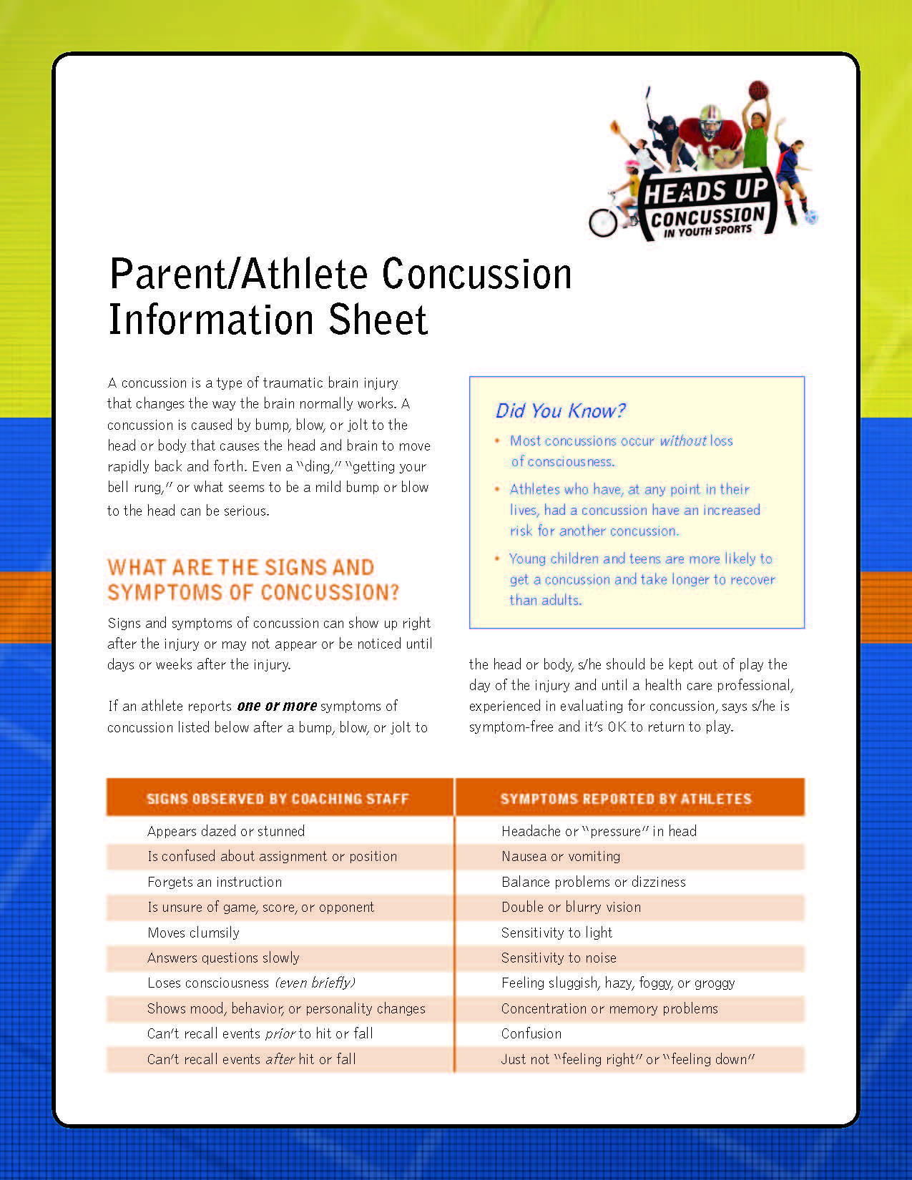

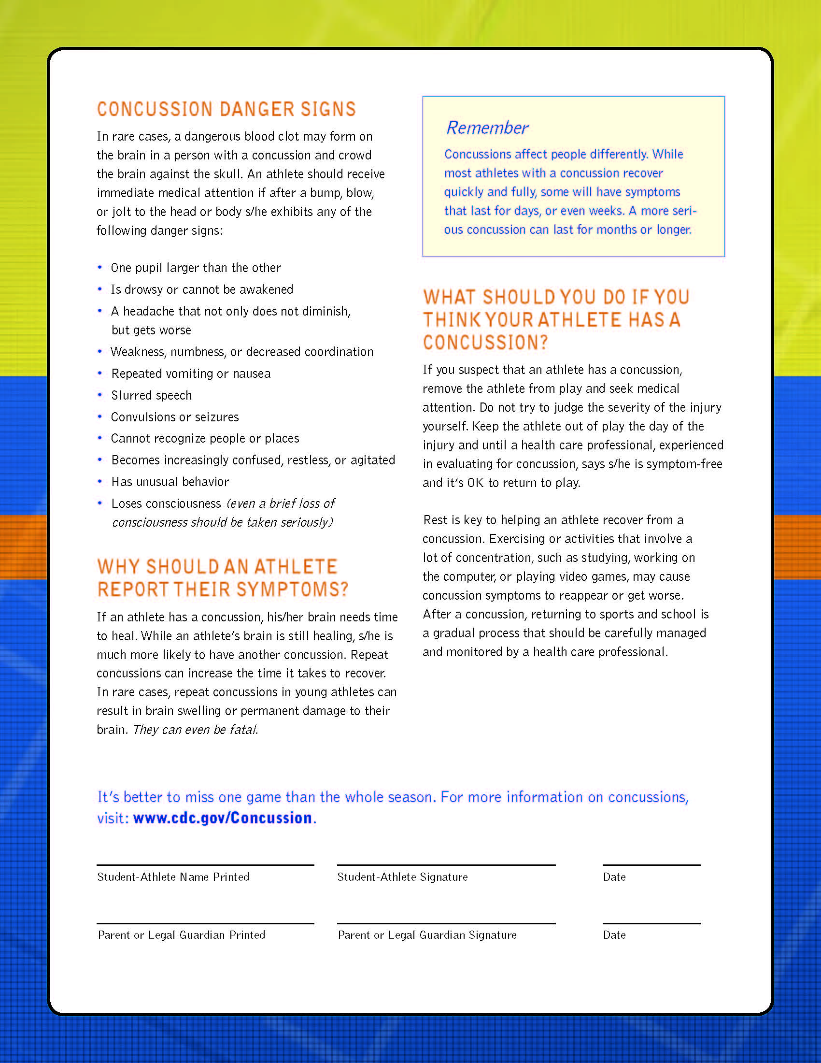

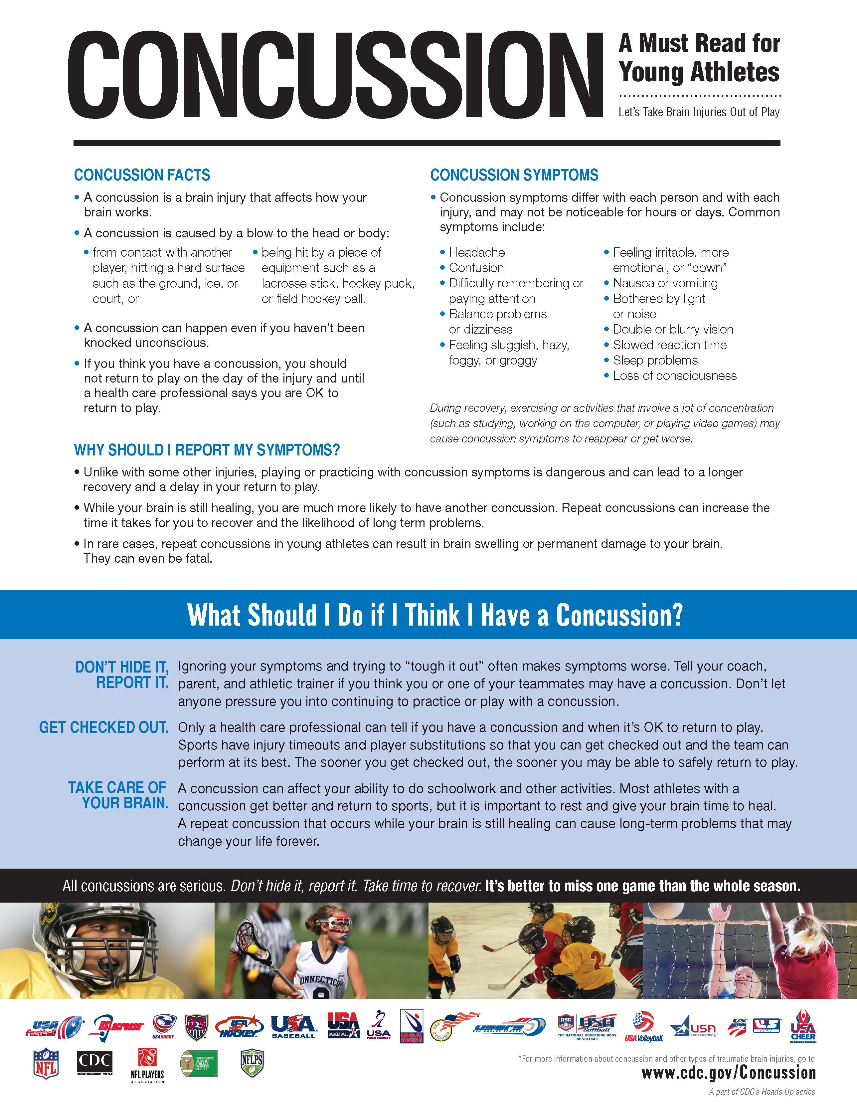

INSURANCE- All students who participate in the interscholastic athletic programs are covered by school provided medical insurance. This insurance is secondary or excess coverage insurance. The parent/guardian's insurance provides the primary coverage. If a parent or guardian does not have medical coverage, then the school's insurance will provide coverage but it will be less than full coverage. Parents should contact the school nurse’s office for assistance.

QUITTING A TEAM-A student who quits a team has seventy-two (72) hours to reconsider before being formally dropped from the team. After seventy-two (72) hours, a player may not return to the team and may not go out for another team during that season. If a student desires to return to the team during the 72 hour window, coach, student and parent must meet to resolve the issue.
If a student quits a sport mid-season, he/she will not be allowed to practice with the next season's sport until the in-season sport has finished AND/OR depending on the circumstances, may not be allowed to participate in the next season. This includes postseason championship play. No student may quit a team without discussing the reason for leaving the team with his/her coach. All equipment issued to the student who quits must be returned. If a student wishes to change sports during a season, he/she may do so with the approval of the Athletic Director and both coaches. He/she must pick up the correct form from the Athletic Director.

CARE OF EQUIPMENT, UNIFORMS, AND FACILITIES-All equipment and uniforms issued by the school to athletes are the property of the NP School District. All uniforms and equipment issued becomes the responsibility of the individual athlete. Any equipment not returned at the end of the season must be paid for or replaced by the student. Failure to do this will result in suspension from further participation in athletic contests. New uniforms are purchased in a rotating cycle. By law the district may not purchase personal items of clothing.
** PLEASE NOTE*** Any item with an athlete’s name/number on it has been purchased by the athlete either personally or through team fund raising. These are personal items of clothing and are not purchased by the district.

Misuse of Equipment and Facilities: All equipment and facilities should be cared for as if they were the athlete's personal property. Any equipment intentionally misused will be repaired at the player's expense.

The Athletic Placement Process (BOE policy 7420, 6/3/15)
The Board recognizes that the New York State Education Department (NYSED)/ New York Public High School Athletic Association’s (NYSPHSAA) The Athletic Placement Process was designed for mature and exceptionally skilled students to advance to a higher level of competition. The program is not to be used to fill positions on teams. It is aimed at the very few select students who can benefit from such placement because of their level of readiness and expertise. Only the exceptional athlete is permitted for classification to a higher level of competition. Based on this purpose the district’s policy for eligibility to advance to a higher level of competition is as follows:

1. Students in seventh grade may not classify up to a high school team at any time if a Modified Program is offered in a given sport. Eighth graders who have successfully completed a year in a modified sport may attempt to classify up to JV.

2. If no JV level is offered only then may students attempt to qualify for the Varsity level.

3. Requests for Athletic Placement may be generated from one or more of the following: Director of Athletics, Physical Education teacher, coach or member of the family in question

4. In order to be eligible for advanced level of competition students must:
Be in good academic standing
Pass all components of the fitness and maturity assessment.

5. Students who satisfy the requirements of the Athletic Placement process in a particular sport may have to satisfy additional physical skills testing and/or maturity level ratings if they elect to participate in the Athletic Placement process for another sport. Physical skills testing and maturity level are sport specific. Athletic Placement results are valid for the duration of a student’s enrollment in the 7th and 8th grade for that particular sport.

6. A student who does not meet the criteria as a 7th grader to selectively classify to a higher level may try again as an 8th grader for that particular sport. A student who does not qualify as a 7th or 8th grader may still try out for any of these teams when he/she reaches 9th grade, the age/grade appropriate level for Junior Varsity (JV) and Varsity, without taking the Athletic Placement Test.

7. A student may attempt to classify for one sport per season, Fall, Winter, Spring. Inability to qualify during one season does not preclude attempting to qualify during a subsequent season.

8. The Board directs the Superintendent to implement the procedures and maintain a file of those students deemed eligible as a result of the Athletic Placement process and procedures.

The athlete must pass the Athletic Placement Fitness test and be approved by the school physician. An Athletic Placement process referral should be initiated by a higher level coach. Forms may be obtained from the school. In order for a student to be approved for Athletic Placement, he or she must be approved by all of the following: Athlete’s Parents, Guidance, Principal, Athletic Director, and Superintendent.

As per NYSPHSAA this process MAY NOT be used to fill Varsity or JV teams if there are inadequate numbers of 9-12 graders to field a squad.

PARENT/COACH COMMUNICATION-. As parents, when your children become involved in our program, you have a right to understand what expectations are placed on your child. This begins with clear communication from the coach of your child’s program.

What you should expect from your child’s coach:
- Program Philosophy and expectations for your child
- Locations and times of all practices and contests.
- Team requirements, i.e., special equipment, off-season conditioning.
- Procedure should your child be injured during participation.
- Discipline for infractions of team and/or school rules

What coaches expect from parents
- Concerns expressed directly to the coach, not to other parents or players
- Notification of any schedule conflicts well in advance
- Support for the team, coach and program.
- Refraining from “side-line” coaching
- Reinforcement and modeling of positive, supportive behavior

As your children become involved in programs at New Paltz, it is important to understand that, along with the good times there may be times when things do not go the way you or your child wishes. At these times, discussion with the coach is encouraged.

Appropriate concerns to discuss with coaches
- The treatment of your child, mentally and physically,
- Ways to help your child improve,
- Concerns about your child’s behavior

Coaches are professionals. They make judgment decisions based on what they believe to be the best for all athletes involved with their team/program. As you have seen from the list above, certain things can be and should be discussed with your child’s coach. Other things, such as those on the following page, must be left to the discretion of the coach.

The following are a coach’s decision
Playing time, Playing position, Team strategy, Play calling, Other student/athletes.
Athletes earn playing time at all levels based on the structure of the league/state requirements along with their effort, coachability, attitude, sportsmanship, attendance and skill during practices and games involving New Palt6z District athletics. Outside clubs and recreational sports do not play a role in MS/HS ball.

There are situations that may require a conference between the coach and the parent. It is important that both parties involved have a clear understanding of the other’s position. When these conferences are necessary, the following procedure should be followed to help promote a resolution to the issue of concern.

Please do not confront a coach before or after a contest or practice. These can be emotional times for both the parent and the coach. Meetings of this nature do not promote resolution.

Procedure to follow to discuss a concern with a coach- Ask the coach for an appointment to meet and give a specific reason or two. Call the Secretary of the NP Athletic Department at 256-4151, to set to set up an appointment or leave a message with the coach. If the coach cannot be reached, call the NP Athletic Director. Arrangements for the meeting will be made for you.

What Can A Parent Do If The Meeting With The Coach Did Not Provide A Satisfactory Resolution? Call the Athletic Secretary to set up an appointment with the Athletic Director. The parent/guardian, coach and Athletic Director will meet to discuss the problem. At this meeting, the appropriate next step can be determined. Parents are encouraged to discuss issues and problems with the Athletic Director. However, if a parent has specific complaints regarding a coach, then the coach must have the opportunity to be present to meet with the parent.

TRANSPORTATION- All athletes MUST travel to and from all away contests and off campus practice sites on school provided transportation. Athletes arriving at away sites on other than school provided transportation will not be permitted to dress or participate in that contest. A player may be released to his/her parents after the parent fills out the transportation release form with the coach. Team members may be released to another adult with written parental permission and Athletic Director approval. A note must be presented by 11 am on the day of the request. All notes must have a parent phone number. Notes will be confirmed with the requesting parent. Inability to confirm the note will result in denial of the request. Notes which are presented late in the day risk denial. (students will NOT be released to other students). All athletes are required to observe all district transportation rules and regulations while on board the bus. On rare occasions special exceptions to the transportation guidelines may be made by the Athletic Director and the Principal.

WE ARE ALL HIGHLY CONCERNED WITH YOUR CHILD’S SAFETY. ATHLETES WHO DRIVE TO OFF-SITE PRACTICES WILL BE SENT HOME. DISCIPLINARY ACTION MAY RESULT.

LATE SPORTS BUS- The district operates late sports buses during all 3 sports seasons to take athletes home after practice.

VARSITY LETTER REQUIREMENTS- An Athlete must:
A. Be a member of the team for the entire season and finish in good standing.
B. Attend all practices and contests unless excused by the coach for a valid reason.
C. Be recommended by his/her coach.
D. Participate as follows:
Baseball Fifty percent (50%) of the games. (exclusive of the pitcher)
Basketball Fifty percent (50%) of the quarters. On the squad for the entire season.
Cross Country Score better than the 5 runner of the opponents
Football Fifty percent (50%) of the quarters.
Golf Fifty percent (50%) of the scoring matches.
Gymnastics Ninety percent (90%) of the meets.
Lacrosse Fifty percent (50%) of the games
Nordic Ski Ninety percent (90%) of the meets.
Soccer Fifty Percent (50%) of the quarters
Softball Fifty percent (50) of the games(exclusive of the pitcher)
Swimming Fifty percent (50%) of the scoring matches.
Tennis Fifty percent (50%) of the scoring matches.
Track Score fifteen (15) points. Five (5) points for each runner on winning relay team)
Volleyball Fifty percent (50%) of the total matches.
Wrestling Total of nine (9) points.

A Participation Certificate will be awarded to any Junior or Senior who meets requirements A, B, and C but does not meet the letter earning requirements. Junior Varsity Awards will be given to all members of Junior Varsity teams and Freshmen and Sophomores on teams that are only Varsity, and who complete requirements A, B, and C. Only one Chenille Varsity and Junior Varsity letter will be awarded to athletes during their high school athletic career. When letters are renewed or additional letters are earned, certificates and metal inserts will be awarded.

Students who participate on Middle School Modified Athletic teams, and who meet requirements A, B, and C will be awarded a certificate by the New Paltz Athletic Association.

New Paltz Athletic Association END OF THE YEAR ATHLETIC AWARDS
A Sportsmanship Award plaque is given to one member of each team for outstanding contribution to the team through dedication and good sportsmanship. Winners are selected by their coaches.
Gym Banners are awarded to all League and Section #9 Championship teams
A Senior Plaque will be awarded to seniors who earn a minimum of four (4) Varsity letters with at least two (2) letters earned in two (2) different sports.
Coaches vote each season on the following three awards. All Senior athletes are considered.
The All Sports Award is presented by the New Paltz Athletic Association to a Senior boy and a Senior girl who have demonstrated outstanding ability and leadership in a variety of sports throughout four (4) high school years. The winners are selected by the Varsity and Junior Varsity Coaches and the officers of the New Paltz Athletic Association.
The Lawrence Johnson Memorial Award plaque is presented to one senior boy and one senior girl who have exemplified the qualities of sportsmanship, desire and excellence. The winners are selected by the Varsity and Junior Varsity Coaches and the officers of the New Paltz Athletic Association.
The John Ford Award- is given to a male and a female athlete who have made outstanding contributions to the athletic program.
Only school sponsored athletic awards will be given out at the Annual Athletic Awards Dinner sponsored by the New Paltz Athletic Association. Coaches who desire to give out individual awards may do so at the end of the season pizza party sponsored for each Varsity and JV team by the New Paltz Athletic Association.

THE NEW PALTZ ATHLETIC ASSOCIATION
The New Paltz Athletic Association is the only booster club for all New Paltz High athletic teams. Its purpose is to benefit all student athletes representing New Paltz Central Schools. Individual sports booster clubs are not allowed. Each sports team is asked to have a parent representative attend the Athletic Association meetings during their respective sports season. The Association is always in need of new members, please call the athletic office for further information.

POTENTIAL SPORTS OFFERINGS The sports listed may be offered providing certified coaches can be secured and enough students participate to field a team.
Fall Season
Varsity Football Junior Varsity Football Modified Football
Varsity Boys Soccer Junior Varsity Boys Soccer Modified Boys Soccer
Varsity Girls Soccer Junior Varsity Girls Soccer Modified Girls Soccer
Varsity Girls Tennis Varsity Girls Swimming Modified Volleyball
Varsity Volleyball Junior Varsity Volleyball Modified Cross Country
Varsity Boys Cross Country Varsity Girls Cross Country Varsity Boys Golf

Winter Season
Varsity Boys Basketball Junior Varsity Boys Basketball Modified Boys Basketball
Varsity Girls Basketball Junior Varsity Girls Basketball Modified Girls Basketball
Varsity Wrestling Junior Varsity Wrestling Modified Wrestling
Varsity Boys Nordic Ski Varsity Girls Nordic Ski
Varsity Boys Swimming Varsity Gymnastics

Spring Season
Varsity Baseball Junior Varsity Baseball Modified Baseball
Varsity Softball Junior Varsity Softball Modified Softball
Varsity Boys Track Varsity Girls Golf Modified Boys Track
Varsity Girls Track Varsity Boys Tennis Modified Girls Track
Varsity Girls Lacrosse Varsity Boys Lacrosse

Other information can be found along with Permission Slips and Physical forms at http://www.newpaltz.k12.ny.us/ Under Our Departments-Athletics

Special thanks for their input and efforts with the current revisions to our handbook to:
The NY State Public High School Athletic Association,
The New Paltz Athletic Association
The Mid-Hudson Athletic League Athletic Directors,
The New Paltz High School Student Government
The New York State Athletic Administrators Association,
New Paltz Athlete, Coaches & Parents.

Take a moment and reflect on your fan appeal-

The following is taken from The Sport Parent’s Manual by Tom Doyle.

“Things parents do that embarrass their kids!
- Try teaching me how to do something ‘correctly’ after a game.
- Coaching during games even though you aren’t the coach.
- Telling me what I was doing wrong after every game.
- Being asked to leave the field by an official.
- Taunting other players, opponents, refs.
- Acting disappointed with what I am doing instead of reassuring me I will do better next time.
- Going crazy at the refs-because it is not your job. It is the coach’s job to question bad calls.
- Coming to a game drunk or after drinking.
- Yelling things at coaches and getting involved with something that was between the coach and me. It was none of their business.

Things parents do that their kids really appreciate!
- Take time out of your busy schedule to come to games and support what we do.
- Bring snacks after a game.
- Supporting the whole team, not just me.
- Cheering the team even when losing badly.
- Tell us we did a good job.
- Being proud of us even when we didn’t win.
- Being quiet unless cheering with everyone else.
- Never yelling at a coach or ref.
- Making friends with the other parents.
- Telling a ‘negative’ parent to be quiet.”

Be Loud, Be Proud, Be Positive !

