Advanced Studio in Ceramics
Mr. Martin

Two Dimensional to Three Dimensional

Have you ever looked at a beautiful painting or drawing and wished that it wasn’t flat?

Well now is the time to make that artwork come to life in three dimensions.

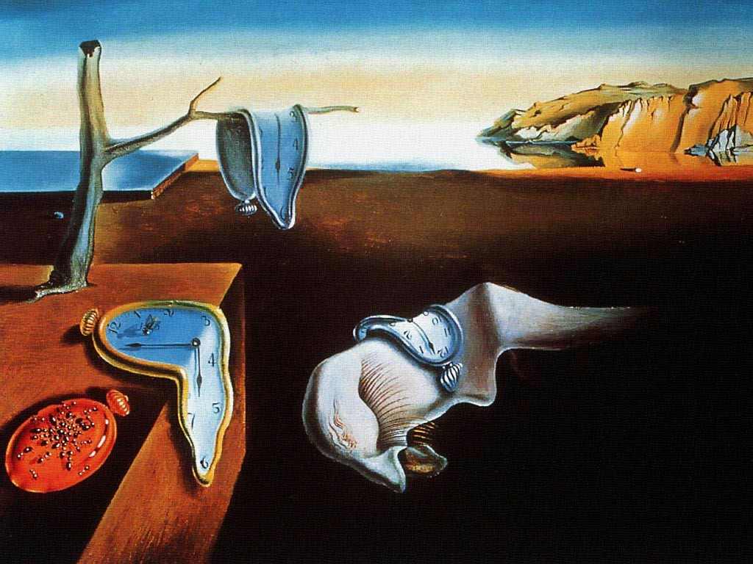

Assignment:
-Find a two dimensional masterpiece of your choice.
-Artwork can come from any movement, style or genre.
-Morph, transform, and interpret the drawing or painting until it becomes a three dimensional work in clay - sculptural or functional.

Notes and research should be written down in your sketchbook.

For each design concept, at least two drawings should be made if it is a relief piece. If it is standing piece, three drawings should made (showing height, width and depth).
Will it be sculptural?

Will it be functional?

What method or methods of construction will you be using?

